EXPERIMENT 3

3.1 PROGRAMS:
3.1.1//Largest of three numbers
ALGORITHM:
Step 1 : Start
Step 2 : Input n1,n2,n3
Step 3 : If n1 > n2 and n1 > n3
Print n1 is largest
el if n2 > n1 and n3 > n2
print n2 is the lagest
else
print n3 is the lagest
loop end
Step 4 : Stop

FLOWCHART:
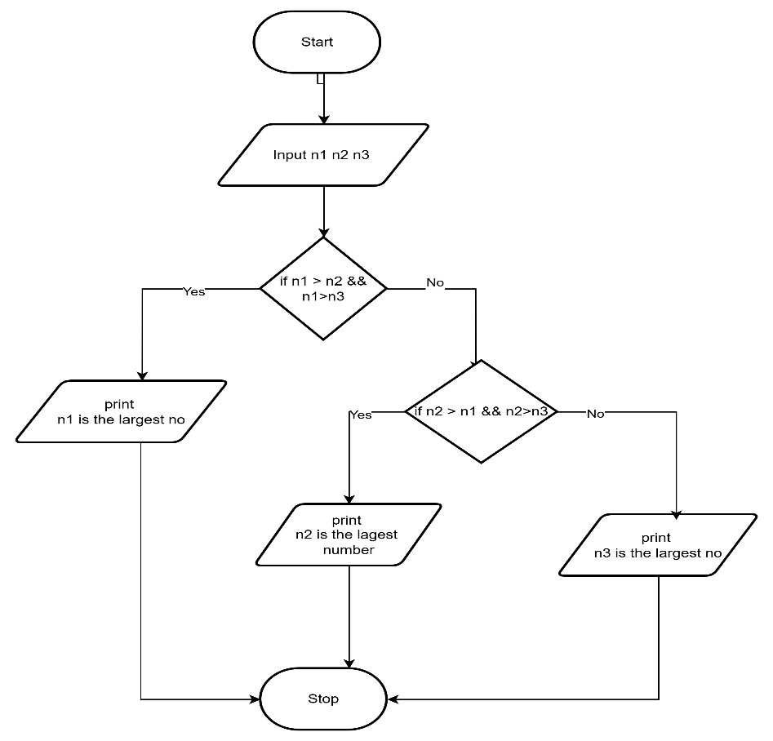
CODETANTRA:
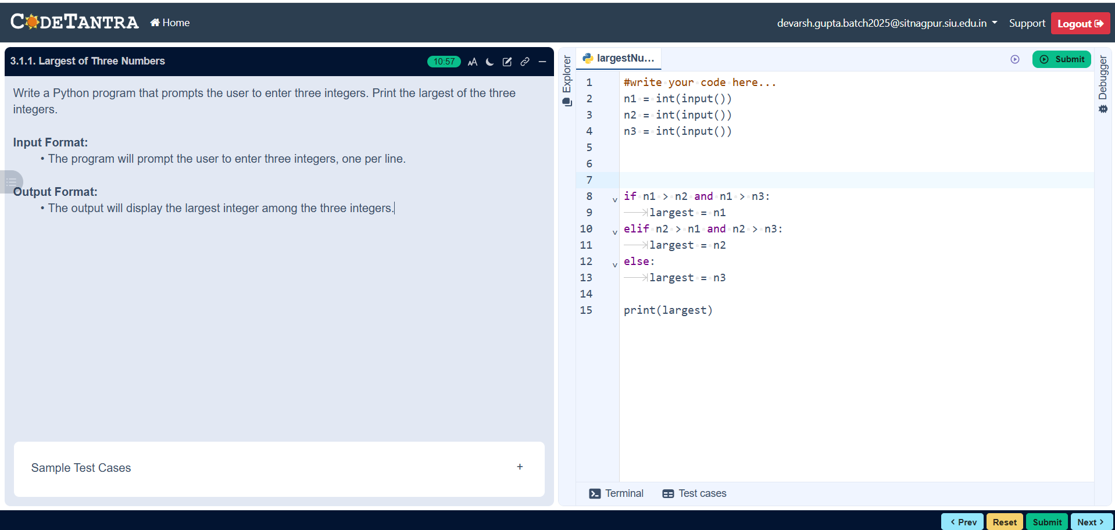

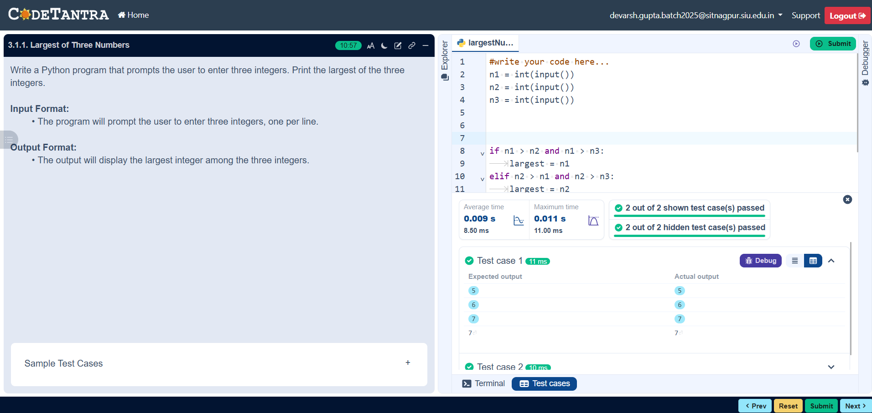

3.1.2//Celsius to farehinheit
ALGORITHM:
Step 1: Start
Step 2: Read temperature in Celsius → C
Step 3: Calculate Fahrenheit using the formula
$$F=(C×\frac{9}{5})+32$$
Step 4: Display value of F
Step 5: Stop
FLOWCHART:
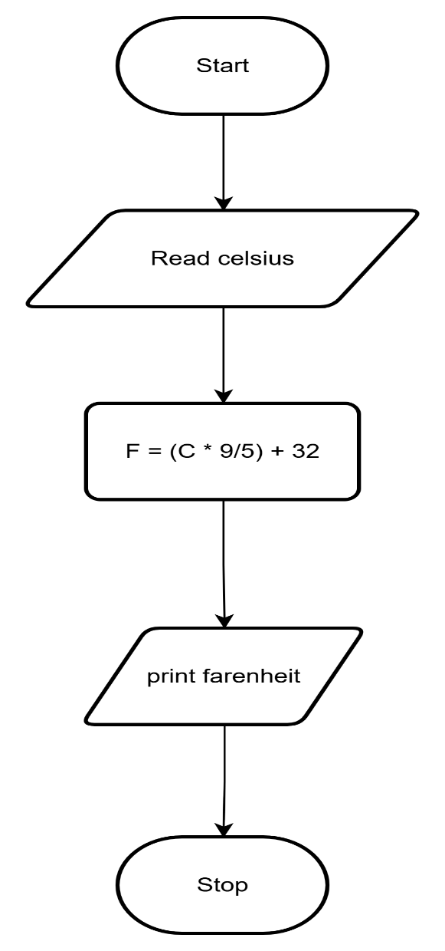
CODETANTRA:
